Multiple ways:

1. Azure Portal

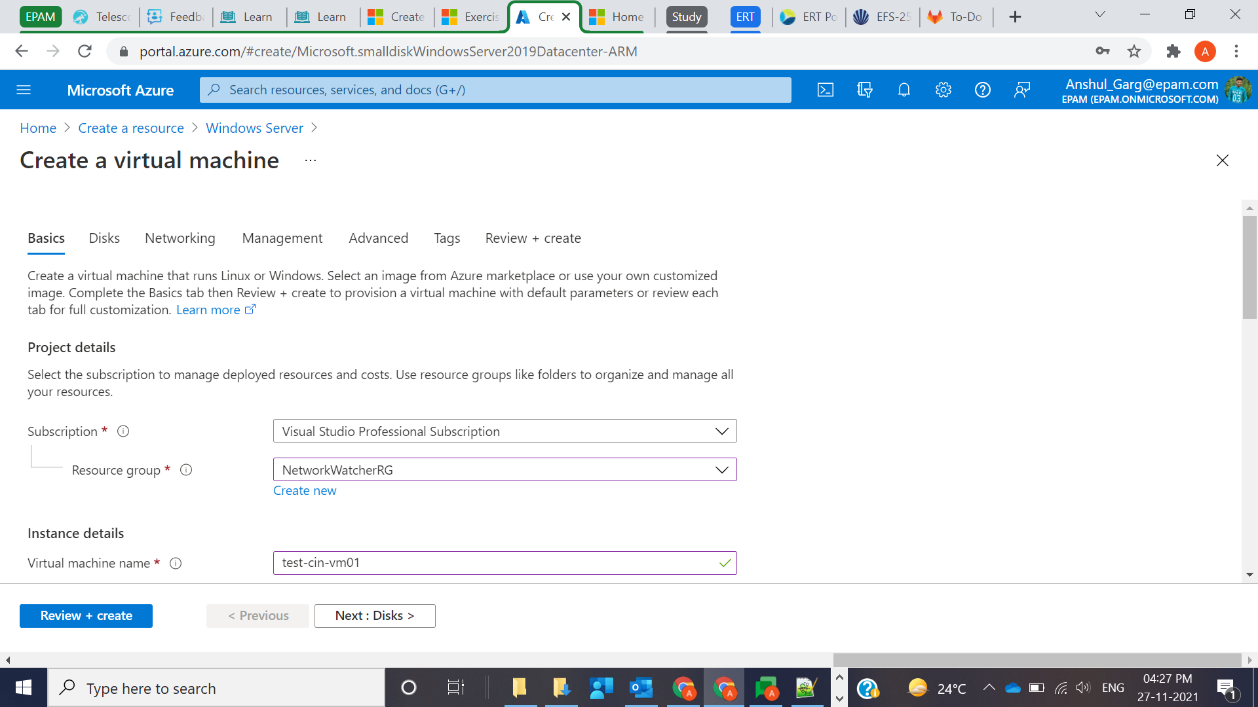

1. Azure CLI or Azure PowerShell
2. Azure Resource Manager Template

Azure Marketplace is also a good place for pre-configured images that include OS and popular software installed.

Credentials:

Anshul/Password@12345